Technical Datasheet W5500-Based Ethernet Module

The Ethernet module communicates with the host controller via a high-speed SPI interface while internally handling the full TCP/IP stack using the W5500 chipset. It supports 10/100 Mbps Ethernet connectivity, enabling reliable and efficient data transmission over standard LAN networks.

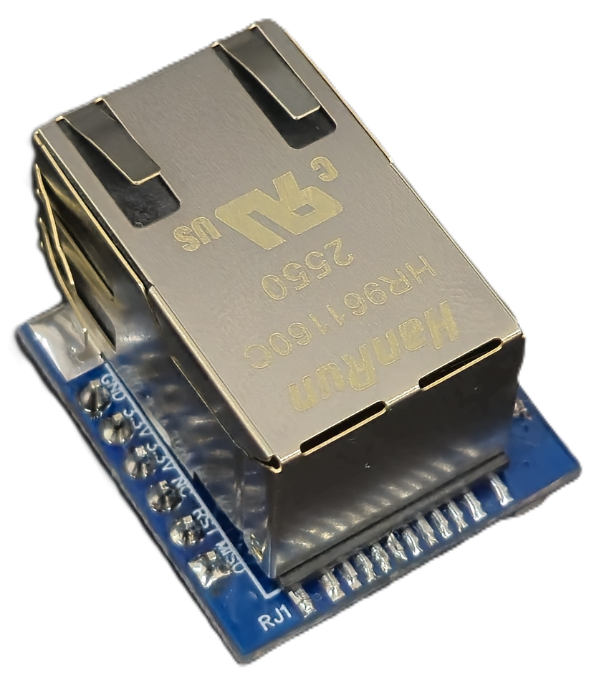
W5500 Module: -

The module is designed in a compact PCB form factor and features an onboard RJ45 connector with integrated magnetics and status indication LEDs. It offers a simple and robust SPI interface for seamless integration with a wide range of microcontrollers, including Arduino, ESP32, STM32, and industrial control systems.
Configuration and communication management are simplified through the hardware TCP/IP stack, significantly reducing firmware complexity and improving overall system performance.

Specifications
General –

Interface SPI (Serial Peripheral Interface)
Ethernet 10/100 Mbps, RJ45 with Integrated Magnetics
I/O Connector 2 × 5 Pin Header, 2.54 mm Pitch
Dimensions 28.3 mm (L) × 55.4 mm (W)

Power Supply 5V DC / 3.3V DC Input
Certifications

Additional Features: -
Integrated hardware TCP/IP stack (W5500)
Supports up to 8 simultaneous socket connections
Onboard RJ45 with integrated magnetics for improved signal integrity
Low firmware overhead due to hardware networking offload
Reliable operation with optimized PCB layout and power decoupling

Note: -
Use standard CAT5e or higher Ethernet cable for reliable network communication
Ensure proper grounding and stable power supply for optimal performance
SPI lines should be kept short and properly routed to minimize signal noise

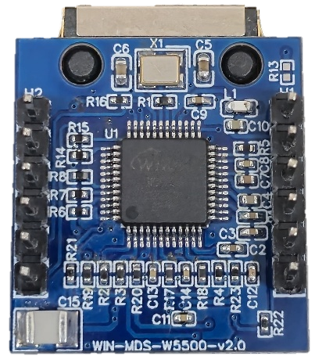
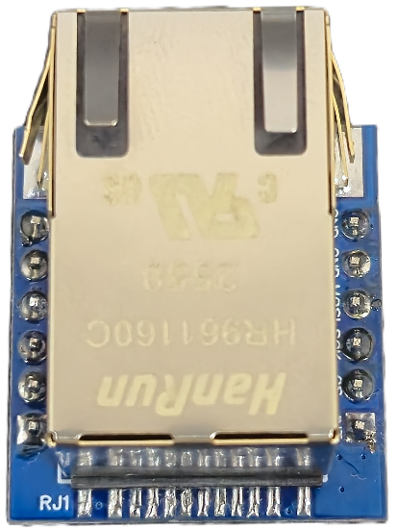

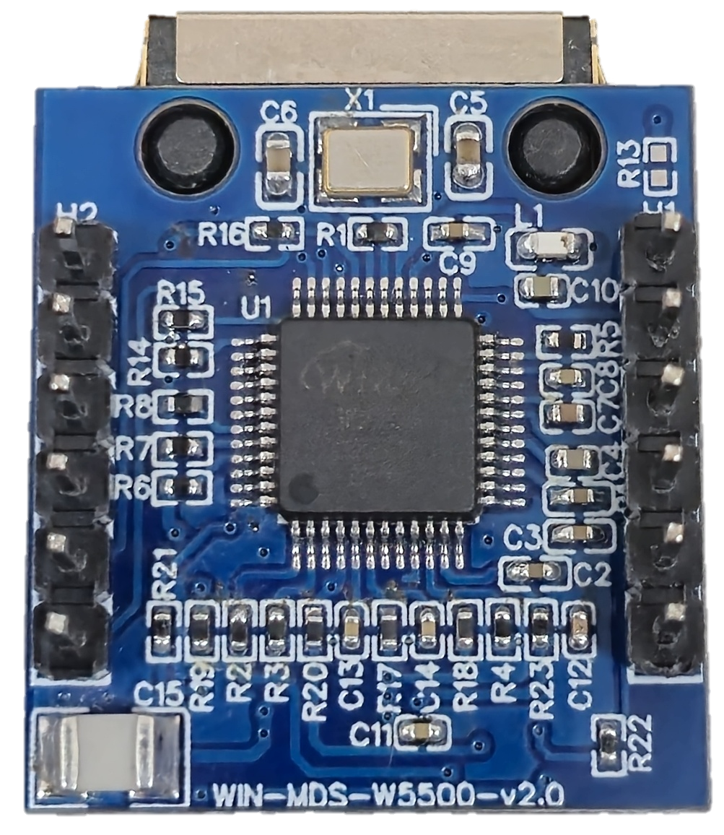
ETHERNET
PORT
Common GNDD
3.3V Input Supply

SPI INTERFACE
RESETn
Common GNDD
INTn

RE

Contact us: -
Augmatic Technologies Pvt. Ltd.,
Plot no 6, Shah Industrial Estate II,
Kotambi,
Vadodara – 391510.
Email – Sales@wittelb.com

